Level-6

Final Project

Digital Shop

By

Gagandeep Singh

Table of Contents

Project Proposal 3

Goals and Objectives 3

Project Scope 3

Project Deliverables 4

Project Specifications 4

Target Audience 4

Project Tasks and Milestones 4

Resource Requirements 6

Project Risks 6

Software Project Report 8

Analysis 8

Requirements Analysis 8

Detail Design 9

Home Page 9

Registration Page 9

Login Page 10

User Product Page 10

User Product Detail Page 11

User Shopping Cart Page 11

User Transaction Checkout Page 11

Admin Registration Page 12

Admin Product Page 12

Admin Customer Page 13

Admin Customer Transaction Page 13

Project Testing 14

System Usability Testing 14

Testing 14

Testing Analysis 19

User Manual 24

Quick Setup Guide 24

User Setup 24

Admin Setup 24

General Information 24

System Overview 24

System Summary 24

System Configuration 24

User Access Levels 24

# Project Proposal

## Goals and Objectives

The goal of this project is to implement an online shopping app which will sell electronics goods. In this application there are two types of user’s admin and normal user. Admin can add, edit and delete any electronic items whereas, normal user can buy from the app. He has access to the shopping cart and can add items in the wish list and buy them later.

## Project Scope

This is a 20 days project in which I have implemented an online shopping application named Digital Shop. The scope of this project is to sell electronics good. And to highlights the available products. New user can register themselves to the application and can buy electronic items.

## Project Deliverables

This project will require certain deliverables. The table below outlines these deliverables.

|  |  |
| --- | --- |
| **Deliverable** | **Description** |
| Final Report | This document. Introduces the project and elaborates its details and requirements. Also states the milestone, schedule, hardware and software requirement and other important details. |
| Executable Programme | This will be the executable code of the project. |
| User Documentation | This will show how one can use the web application |
| Test Plan | This will provide the test detail of the project |

## Project Specifications

* Secure log in and registration by user
* Edit and delete of accounts by the admin
* Admin can add, edit and update digital products
* User can buy new products and also can save the products in Wishlist.

## Target Audience

Normal user and anyone who is keen to buy electronic good age from7years and can go up to 100 years.

## Project Tasks and Milestones

The table below shows the Project Tasks and Milestones

|  |  |  |  |  |  |  |  |  |  |  |  |  |  |  |  |
| --- | --- | --- | --- | --- | --- | --- | --- | --- | --- | --- | --- | --- | --- | --- | --- |
| Project Stages | Major Activities | Week1-2 | | | | Week-2-3 | | | | | Week-3-4 | | | | |
| Planning | Technology Research |  |  |  |  |  |  |  |  |  |  |  |  |  |  |
| Kick off Meeting |  |  |  |  |  |  |  |  |  |  |  |  |  |  |
| Project Proposal |  |  |  |  |  |  |  |  |  |  |  |  |  |  |
| Proposal Documentation |  |  |  |  |  |  |  |  |  |  |  |  |  |  |
| Execution – 1 | Database Design |  |  |  |  |  |  |  |  |  |  |  |  |  |  |
| User Interface Design |  |  |  |  |  |  |  |  |  |  |  |  |  |  |
| Identity Framework implementation |  |  |  |  |  |  |  |  |  |  |  |  |  |  |
| User Interface Implementation |  |  |  |  |  |  |  |  |  |  |  |  |  |  |
| Admin Interface Implementation |  |  |  |  |  |  |  |  |  |  |  |  |  |  |
| Testing |  |  |  |  |  |  |  |  |  |  |  |  |  |  |
| Closing | Final Documentation |  |  |  |  |  |  |  |  |  |  |  |  |  |  |

## Resource Requirements

Following technologies and development method:

* Asp.net MVC Framework
* Identity framework- ASP
* Windows Operating System
* 64-bit Processor and 4 GB RAM

## Project Risks

The following are the identified high-level risks that might affect the completion and success of the project:

* Project delays may cause cascading delay in other dependent tasks.
* Project scope and duration may be underestimated.
* Project must have exceptional security for the system contains confidential information.
* The overall functionalities requested may be beyond what the developer can deliver in the given time available.

|  | **Low (Yes)** | | | | **RISK** | | | | **(No) High** | | | |
| --- | --- | --- | --- | --- | --- | --- | --- | --- | --- | --- | --- | --- |
| 0 | 1 | 2 | 3 | | 4 | 5 | 6 | | 7 | 8 | 9 |
| **Inherent Risks** |  |  |  |  | |  |  |  | |  |  |  |
| **Project Objectives** |  |  |  |  | |  |  |  | |  |  |  |
| Is the project small? |  |  |  |  | |  |  |  | | **●** |  |  |
| Is the project of minor importance to the business? |  |  |  |  | |  |  | **●** | |  |  |  |
| Is the project functionally straightforward? |  |  |  |  | |  |  |  | |  | **●** |  |
| Are several parties able to define the requirements? |  |  |  |  | |  |  | **●** | |  |  |  |
| Is the subject area well documented? |  |  | **●** |  | |  |  |  | |  |  |  |
| Are preceding projects well documented? |  |  |  | **●** | |  |  |  | |  |  |  |
| **User Organisation** |  |  |  |  | |  |  |  | |  |  |  |
| Does the project maintain existing user procedures? |  | **●** |  |  | |  |  |  | |  |  |  |
| Is other organisational change unlikely during the project? |  | **●** |  |  | |  |  |  | |  |  |  |
| Are the users grouped in one location? |  |  | **●** |  | |  |  |  | |  |  |  |
| **Technology** |  |  |  |  | |  |  |  | |  |  |  |
| Is tried hardware being used? |  | **●** |  |  | |  |  |  | |  |  |  |
| Can custom programming be avoided? |  |  |  |  | |  |  |  | | **●** |  |  |
| Is the project technically straightforward? |  |  |  |  | |  |  |  | |  | **●** |  |
| Is the quality of existing data good? | **●** |  |  |  | |  |  |  | |  |  |  |
| **Acquired Risks** |  |  |  |  | |  |  |  | |  |  |  |
| **Scope and Approach** |  |  |  |  | |  |  |  | |  |  |  |
| Is the project scope well defined and agreed? |  | **●** |  |  | |  |  |  | |  |  |  |
| Is the project approach well defined and agreed? |  | **●** |  |  | |  |  |  | |  |  |  |
| **Project Organisation** |  |  |  |  | |  |  |  | |  |  |  |
| Are people’s roles clearly defined? |  | **●** |  |  | |  |  |  | |  |  |  |
| Are users committed to the project? |  |  | **●** |  | |  |  |  | |  |  |  |
| Are staff able to commit sufficient time to the project? |  | **●** |  |  | |  |  |  | |  |  |  |
| Are the required skills available? |  |  |  |  | | **●** |  |  | |  |  |  |
| Does backup exist for all members of the project? |  |  |  | **●** | |  |  |  | |  |  |  |
| Are political and personal relationships good? |  | **●** |  |  | |  |  |  | |  |  |  |
| Is the project independent of third parties? |  | **●** |  |  | |  |  |  | |  |  |  |
| Can a small group achieve the design? |  | **●** |  |  | |  |  |  | |  |  |  |
| Can a “Big Bang” implementation be avoided? |  | **●** |  |  | |  |  |  | |  |  |  |
| **Experience, Training and Support** |  |  |  |  | |  |  |  | |  |  |  |
| Does the IT team know the technology? |  |  |  |  | |  | **●** |  | |  |  |  |
| Do the users know the technology? |  |  |  |  | |  | **●** |  | |  |  |  |
| Is the technology well supported? |  |  | **●** |  | |  |  |  | |  |  |  |

# Software Project Report

## Analysis

### Requirements Analysis

The requirement analysis covers the functional and non-functional aspects of the system.

#### Functional

The functional requirements of this project is divided into types. One for Authors, and one for Printers.

|  |  |
| --- | --- |
| **Users** | **Functional Requirements** |
| **Admin** | * Login/logout * Manage their existing products, customer and transactions. * Add, delete, edit products * Edit and delete customers * Delete Transactions * Add/register new admins. |
| **Normal User** | * Login/logout * Register as new user * Can buy products. * Add products to Wishlist and Shopping cart. * Delete products from shopping cart * Checkout |

#### Non-Functional

|  |  |
| --- | --- |
| **Operational** | * The system should able to run on all web browsers. * The system should be accessible via mobiles |
| **Performance** | * The system should have a 99% uptime |
| **Security** | * Only Administrators have full access to the system * Normal user can have access to their accounts. |

## Detail Design

### Home Page

This is the main landing page of the application. On this page in the navigation there are 5 menus- products, shopping cart, sign up, login, register admin.



### Registration Page

With the help of this page user can register on Digital shop web application. User needs to enter a valid email and password and need to provide other details and once the form is filled need to click on register.

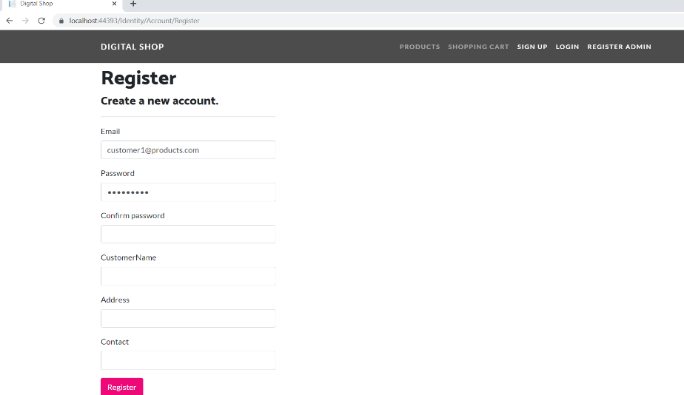

### Login Page

Once user registers successfully with the Digital shop, he/she can login to the application as registered user and continue shopping.

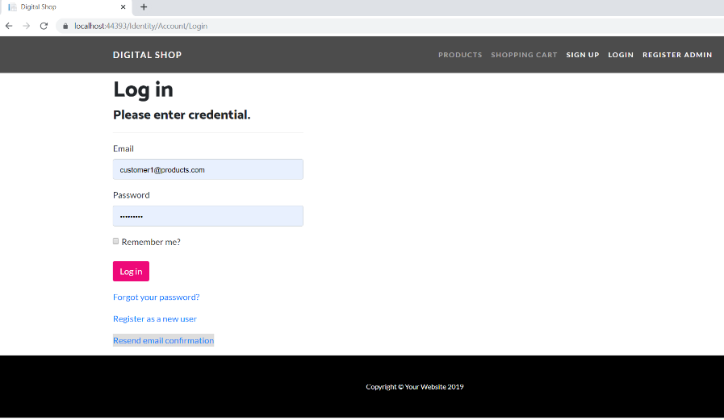

### User Product Page

This page will highlight all the products available for sale by the digital shop including the price. User can see the details of the products by clicking on view button under the products and also can add products in the cart by clicking on the add To Cart button.

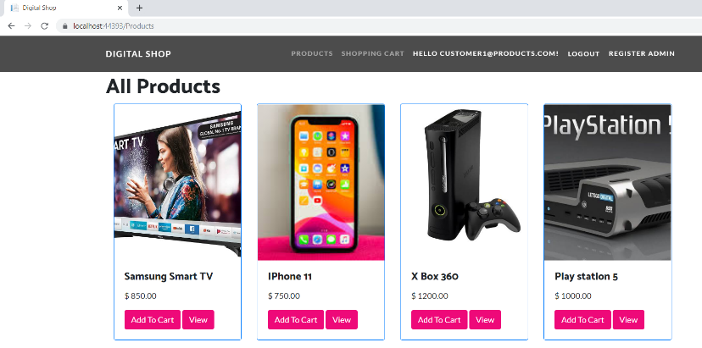

### User Product Detail Page

This page will highlight the details of the available products. When user will click on the view button on the user product page. User will be navigated to User Product Detail Page. Here all the details related to the products will be displayed. User can also go back to the list by click on Back to list link.

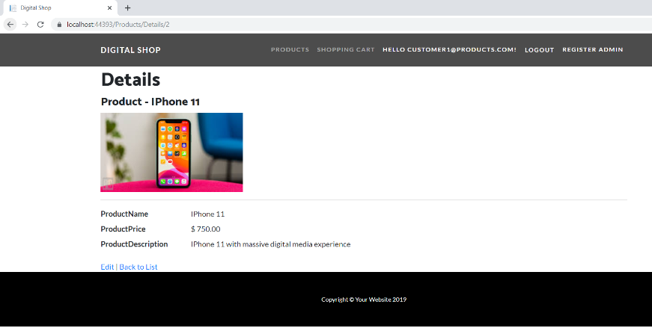

### User Shopping Cart Page

Whenever, user will add any product to the cart it will be stored in the shopping cart and if user wants to see the items added to the cart, he/she can see it with the help of user shopping cart page.

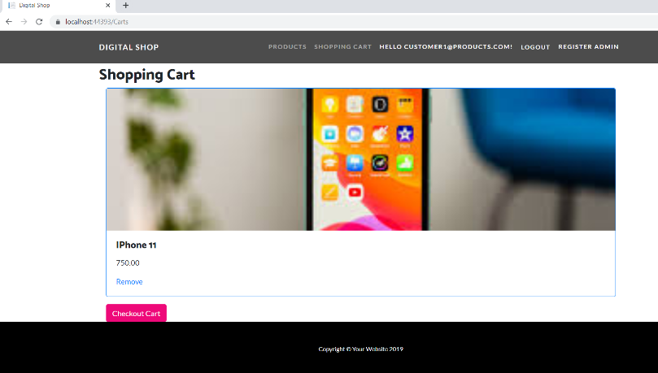

### User Transaction Checkout Page

Once user makes up their mind and click on checkout button, the transaction checkout page will display, and it will show an order number and confirm that the transaction has been processed.

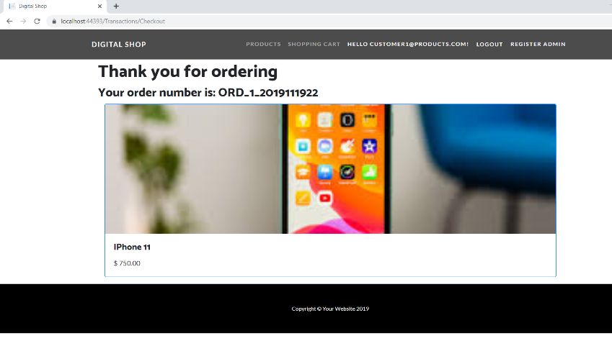

### Admin Registration Page

With the help of this page, admin can register other admin to the application. By entering all asked details to the registration form, one can be added as an admin for the digital shop application.

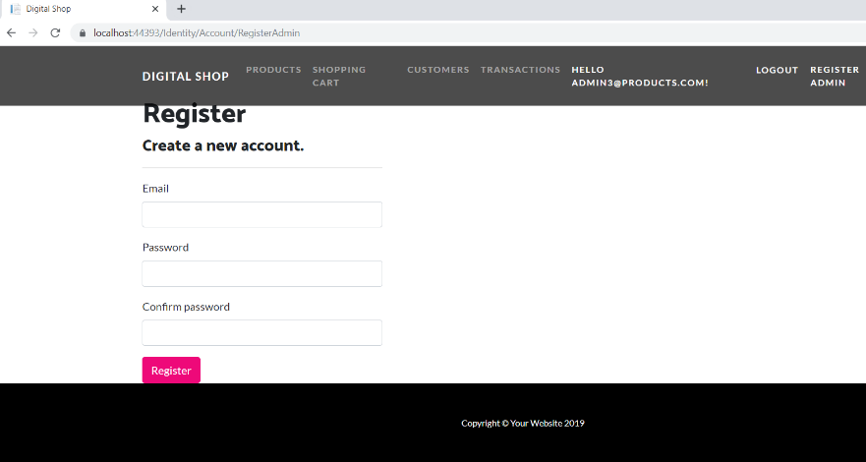

### Admin Product Page

This page will show the available products. Admin can view, edit and delete the existing products as well as can add new products to the site.

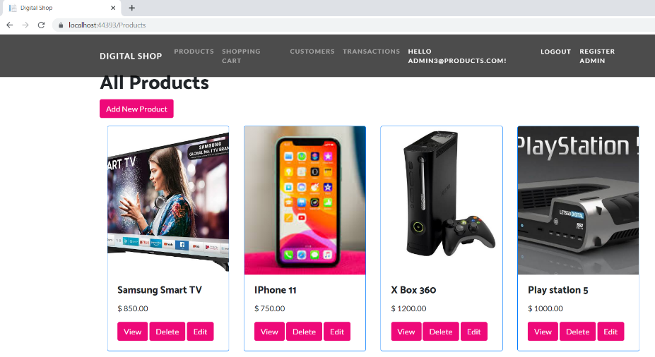

### Admin Customer Page

This page will show the list of all registered customer with Digital shop. Admin can edit, delete and check the details of the customers.

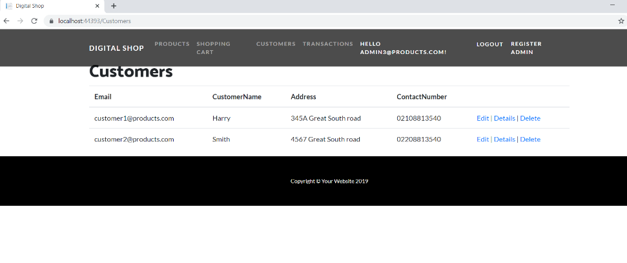

### Admin Customer Transaction Page

This Page will show the transactions made by the customer as well as the product detail, and order id. Admin can see the details of the orders also can delete the orders.

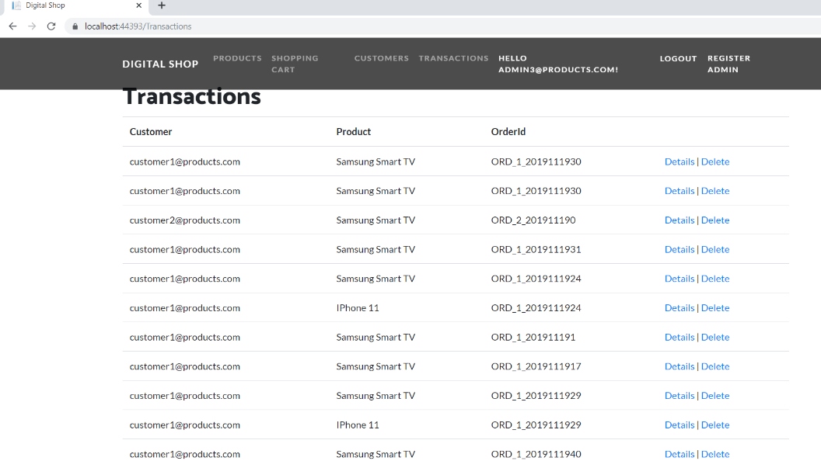

# Project Testing

## System Usability Testing

### Testing

**Tester 1**

|  |  |  |  |  |  |  |
| --- | --- | --- | --- | --- | --- | --- |
| **Tester – 1** | | **Answer Scale** | | | | |
| **No.** | **Question** | **Strongly Disagree (1)** | **Disagree (2)** | **Normal (3)** | **Agree (4)** | **Strongly Agree (5)** |
| 1 | I think that I would like to use this system frequently |  |  |  |  |  |
| 2 | I found the system unnecessarily complex |  |  |  |  |  |
| 3 | I thought the system was easy to use |  |  |  |  |  |
| 4 | I think that I would need the support of a technical person to be able to use this system |  |  |  |  |  |
| 5 | I found the various functions in this system were well integrated |  |  |  |  |  |
| 6 | I thought there was too much inconsistency in this system |  |  |  |  |  |
| 7 | I would imagine that most people would learn to use this system very quickly |  |  |  |  |  |
| 8 | I found the system very cumbersome to use |  |  |  |  |  |
| 9 | I felt very confident using the system |  |  |  |  |  |
| 10 | I needed to learn a lot of things before I could get going with this system |  |  |  |  |  |

**Tester 2**

|  |  |  |  |  |  |  |
| --- | --- | --- | --- | --- | --- | --- |
| **Tester –2** | | **Answer Scale** | | | | |
| **No.** | **Question** | **Strongly Disagree (1)** | **Disagree (2)** | **Normal (3)** | **Agree (4)** | **Strongly Agree (5)** |
| 1 | I think that I would like to use this system frequently |  |  |  |  |  |
| 2 | I found the system unnecessarily complex |  |  |  |  |  |
| 3 | I thought the system was easy to use |  |  |  |  |  |
| 4 | I think that I would need the support of a technical person to be able to use this system |  |  |  |  |  |
| 5 | I found the various functions in this system were well integrated |  |  |  |  |  |
| 6 | I thought there was too much inconsistency in this system |  |  |  |  |  |
| 7 | I would imagine that most people would learn to use this system very quickly |  |  |  |  |  |
| 8 | I found the system very cumbersome to use |  |  |  |  |  |
| 9 | I felt very confident using the system |  |  |  |  |  |
| 10 | I needed to learn a lot of things before I could get going with this system |  |  |  |  |  |

**Tester 3**

|  |  |  |  |  |  |  |
| --- | --- | --- | --- | --- | --- | --- |
| **Tester – 3** | | **Answer Scale** | | | | |
| **No.** | **Question** | **Strongly Disagree (1)** | **Disagree (2)** | **Normal (3)** | **Agree (4)** | **Strongly Agree (5)** |
| 1 | I think that I would like to use this system frequently |  |  |  |  |  |
| 2 | I found the system unnecessarily complex |  |  |  |  |  |
| 3 | I thought the system was easy to use |  |  |  |  |  |
| 4 | I think that I would need the support of a technical person to be able to use this system |  |  |  |  |  |
| 5 | I found the various functions in this system were well integrated |  |  |  |  |  |
| 6 | I thought there was too much inconsistency in this system |  |  |  |  |  |
| 7 | I would imagine that most people would learn to use this system very quickly |  |  |  |  |  |
| 8 | I found the system very cumbersome to use |  |  |  |  |  |
| 9 | I felt very confident using the system |  |  |  |  |  |
| 10 | I needed to learn a lot of things before I could get going with this system |  |  |  |  |  |

**Tester 4**

|  |  |  |  |  |  |  |
| --- | --- | --- | --- | --- | --- | --- |
| **Tester – 4** | | **Answer Scale** | | | | |
| **No.** | **Question** | **Strongly Disagree (1)** | **Disagree (2)** | **Normal (3)** | **Agree (4)** | **Strongly Agree (5)** |
| 1 | I think that I would like to use this system frequently |  |  |  |  |  |
| 2 | I found the system unnecessarily complex |  |  |  |  |  |
| 3 | I thought the system was easy to use |  |  |  |  |  |
| 4 | I think that I would need the support of a technical person to be able to use this system |  |  |  |  |  |
| 5 | I found the various functions in this system were well integrated |  |  |  |  |  |
| 6 | I thought there was too much inconsistency in this system |  |  |  |  |  |
| 7 | I would imagine that most people would learn to use this system very quickly |  |  |  |  |  |
| 8 | I found the system very cumbersome to use |  |  |  |  |  |
| 9 | I felt very confident using the system |  |  |  |  |  |
| 10 | I needed to learn a lot of things before I could get going with this system |  |  |  |  |  |

**Tester 5**

|  |  |  |  |  |  |  |
| --- | --- | --- | --- | --- | --- | --- |
| **Tester – 5** | | **Answer Scale** | | | | |
| **No.** | **Question** | **Strongly Disagree (1)** | **Disagree (2)** | **Normal (3)** | **Agree (4)** | **Strongly Agree (5)** |
| 1 | I think that I would like to use this system frequently |  |  |  |  |  |
| 2 | I found the system unnecessarily complex |  |  |  |  |  |
| 3 | I thought the system was easy to use |  |  |  |  |  |
| 4 | I think that I would need the support of a technical person to be able to use this system |  |  |  |  |  |
| 5 | I found the various functions in this system were well integrated |  |  |  |  |  |
| 6 | I thought there was too much inconsistency in this system |  |  |  |  |  |
| 7 | I would imagine that most people would learn to use this system very quickly |  |  |  |  |  |
| 8 | I found the system very cumbersome to use |  |  |  |  |  |
| 9 | I felt very confident using the system |  |  |  |  |  |
| 10 | I needed to learn a lot of things before I could get going with this system |  |  |  |  |  |

### Testing Analysis

|  |  |  |
| --- | --- | --- |
| **No.** | **Analysis Chart** | **Comment** |
| 1 |  | As per the analysis, it is clear that 40% users are neutral while answering and same percentage of the users are disagree. Because, this application is mainly for the author who is going to write the book. |
| 2 |  | It is clear from the analysis that 80% users are strongly disagree. Whereas, 20% are disagree. Which shows that system is not complex. It is easy to use. |
| 3 |  | It is clear that 80% users are strongly agree and 20% are agree on the easy usage of the system. |
| 4 |  | Only 20% users feel that they need the help of technical person while using this system. |
| 5 |  | Based on the users feedback, it seems that all the functions of the system is well integrated. |
| 6 |  | Users are not agree that system is inconsistent. |
| 7 |  | All users are agree with this statement. |
| 8 |  | Analysis says that the system is not difficult to use. All users feel that system is user friendly. |
| 9 |  | Users are confident while using system. |
| 10 |  | As per the previous responses, it is obvious that users don’t need to learn a lot before using the system. |

# User Manual

## Quick Setup Guide

### User Setup

As a web application, there is no need of any special setup for the targeted users. However, there is need to register through the website to access its features. The web application is accessible through local host.

To register, simply click on the “Register!” on the Log In page.

### Admin Setup

* Admin needs to login using the valid credentials.
* If need to add a new admin, firstly the existing admin will login and register the new admin.

## General Information

### System Overview

Digital Shop is an online shopping app which will sell electronics goods. In this application there are two types of user’s admin and normal user. Admin can add, edit and delete any electronic items whereas, normal user can buy from the app. He has access to the shopping cart and can add items in the wish list and buy them later.

## System Summary

### System Configuration

Digital App is a web application developed using Asp.net MVC Framework. It will run on most modern web browsers and will not require any special system configuration. As a web application, it will require internet connection to function.

### User Access Levels

Only registered users can access the features of Digital shop.

* **Administrators:** Full access to the system and all functionalities. Full access to all stored products and registered customer details.
* **Users:** Limited access to the app. Can only see their accounts and do the shopping.